Enterprise Network 2350

Lab 4.1.1d: Harden Host Devices

GYIMP

Jacob Calvert, Timothy Zellers, Regan Stubbs, James Baker, Faustino Gonzales

Criteria #1a: Antivirus installed

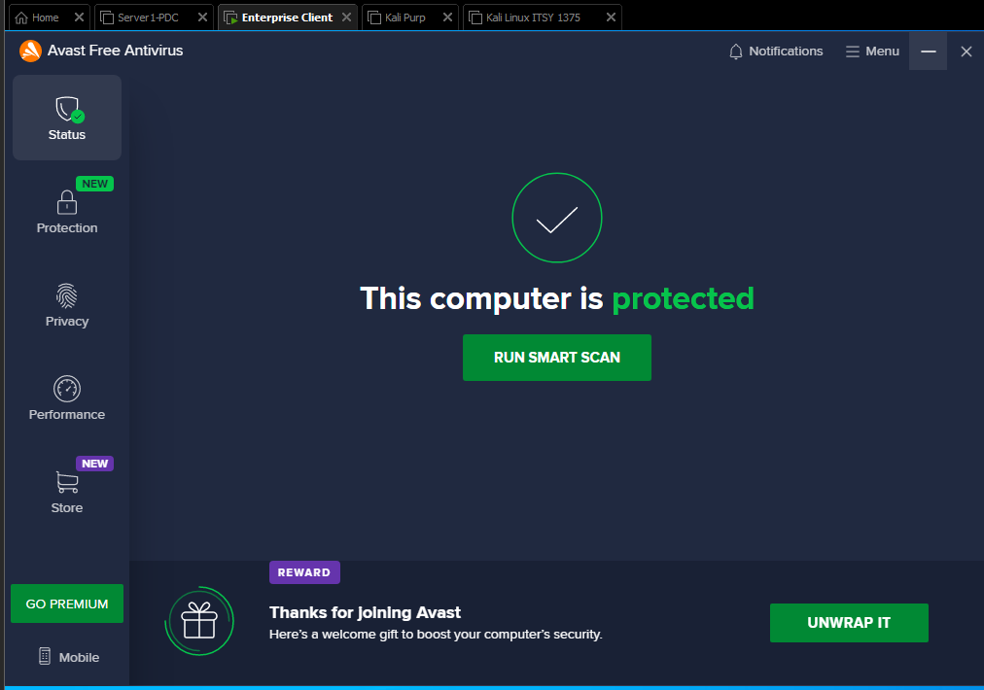

Criteria #1b: Client obtained Antivirus signatures up to date

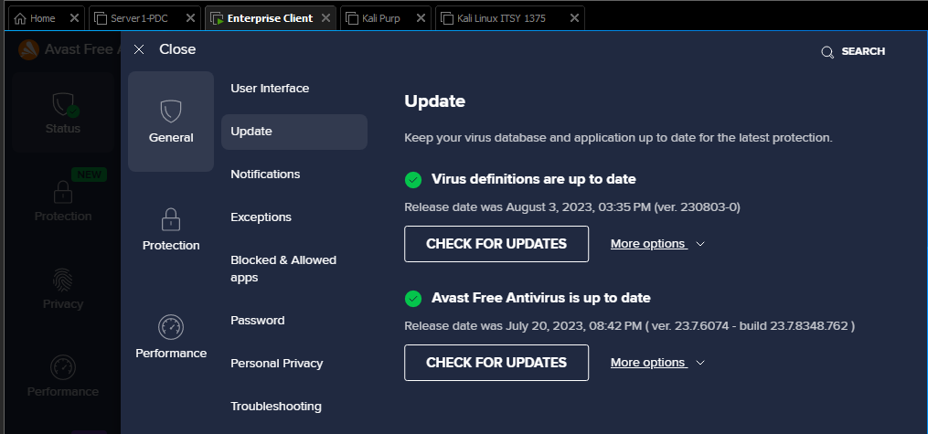

Criteria #1c: Antivirus is scheduled to run daily

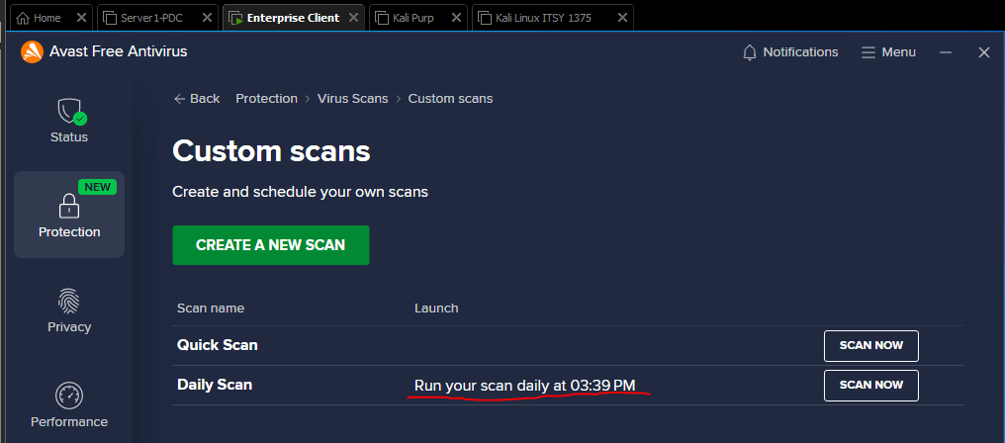

Criteria #2a: Malware protection is installed

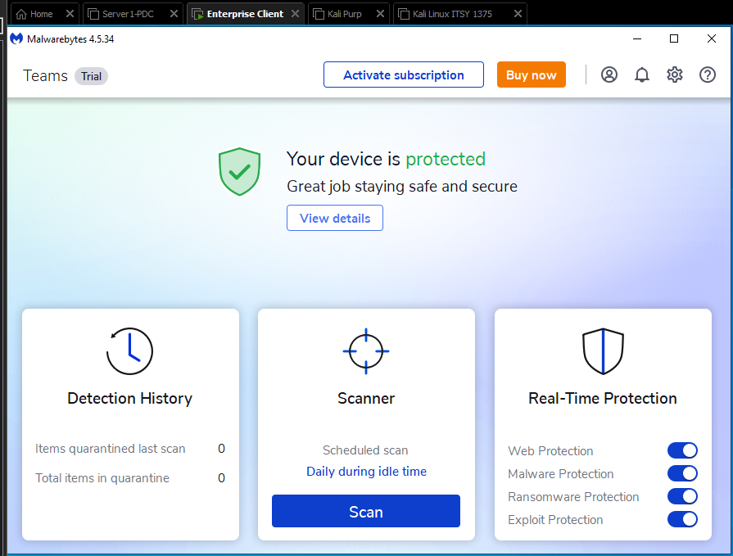

Criteria #2b: Malware protection signatures up to date

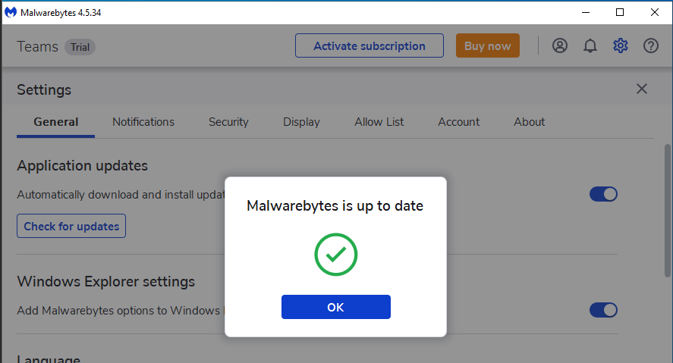

Criteria #2c: Malware protection is scheduled to run daily

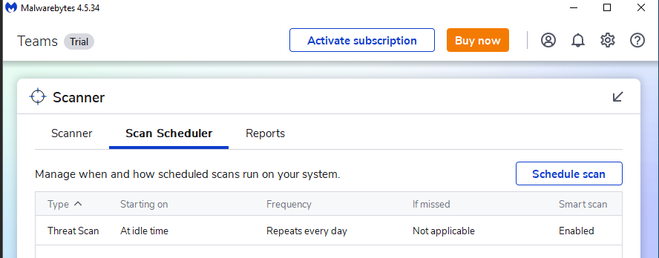

Criteria #3: Secure password is used to login to client computer Hint: Test GPO password settings

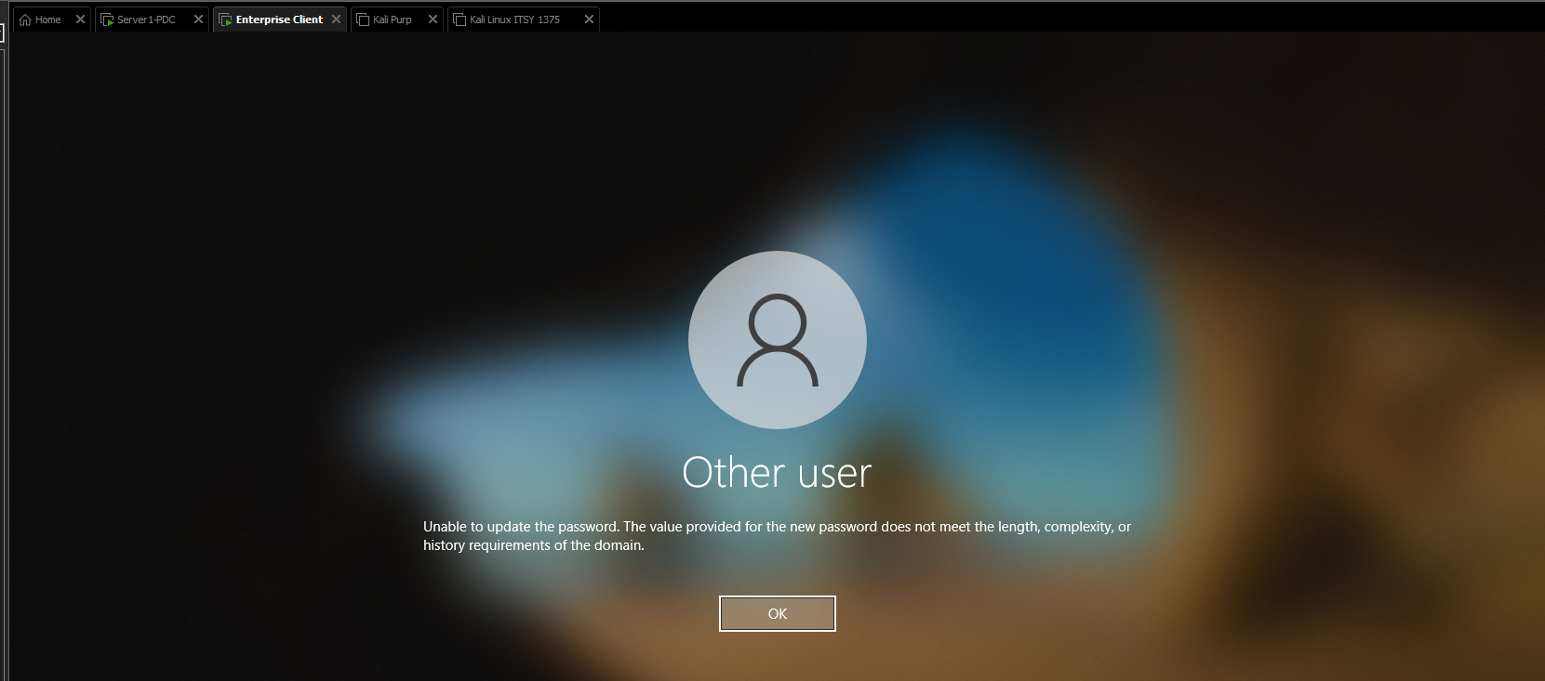



Criteria #4 Browser is configured for secured communication / browsing – https

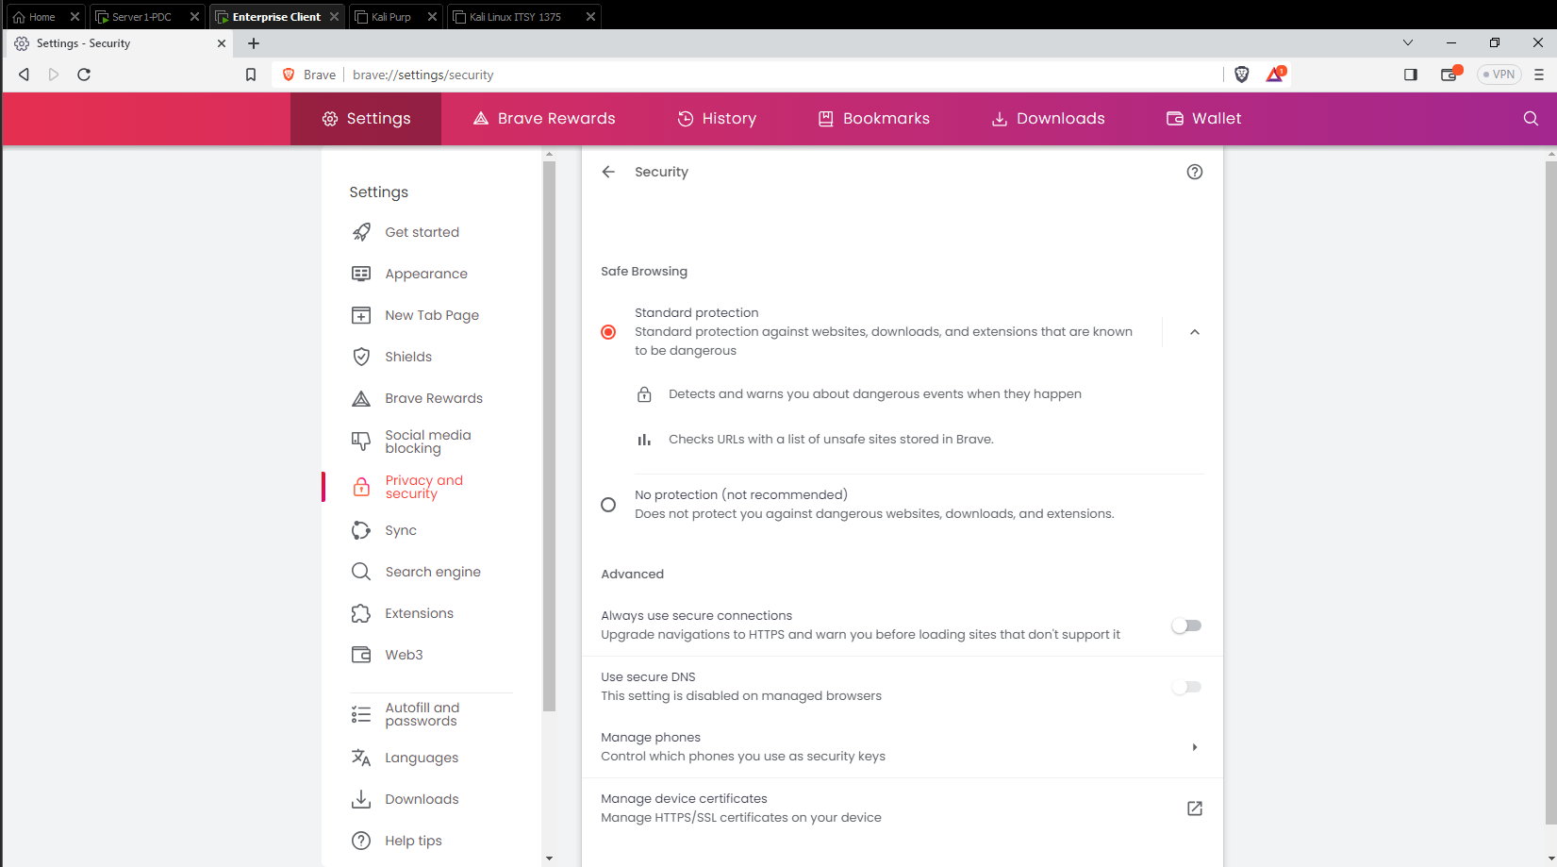

Reflection #1 4 additional items identified to harden client computer

* Use a Password Manager
* Remove unnecessary and unused programs
* Patch management, consistently ensure the OS is patch and up to date.
* Establish group policies. Update user policies and make sure all users are aware of and compliant with these procedures.
* Review the user accounts regularly, to ensure no one has added an account or changed privileges.